**BOMBO PARENTS NURSERY AND PRIMARY SCHOOL**

**TOP CLASS**

**Health Habits**

My name is __________________________________________

1. 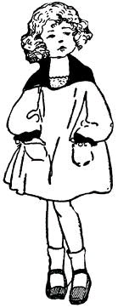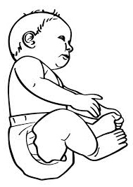**Match people God has created.**

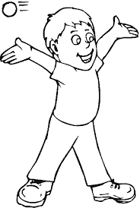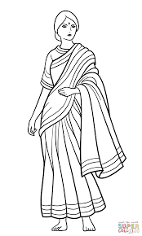

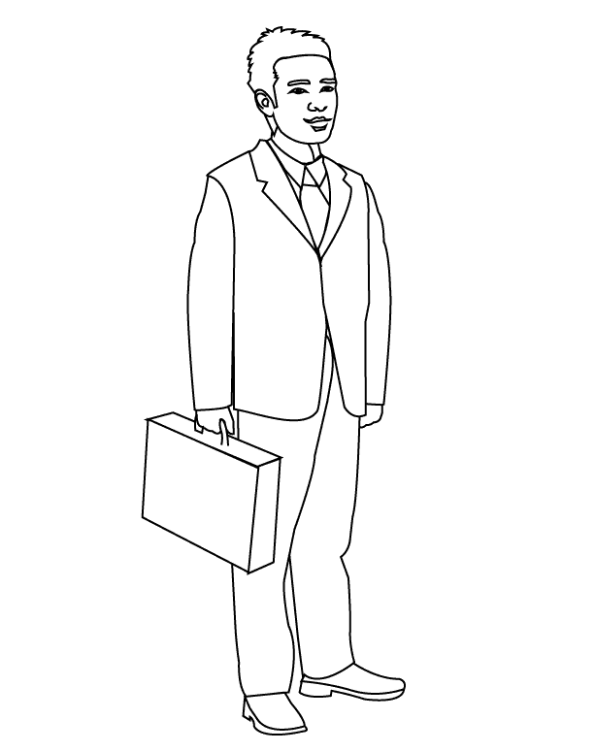









1. **Copy and draw things we use to clean our bodies.**

|  |  |
| --- | --- |
| D:\Local Disk F\New folder\ODONGO\JIREH\DISAN 2020\pic\pics\sponge.jpg | D:\Local Disk F\New folder\DISAN 2020\pic\pics\soap.png |
|  |  |

1. **Copy and write.**

leg eye nose

leg

1. **Read and colour me please.**

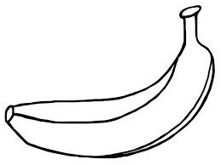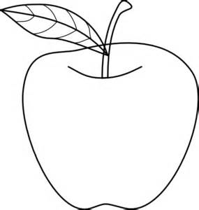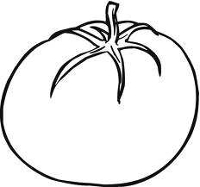

1. **Name the things that can harm us.**

|  |  |  |
| --- | --- | --- |
| D:\Local Disk F\New folder\SECRETARY\NEW PICS\MY PHOTOS\PICTURES\LISA EVE\pin final.png | D:\Local Disk F\New folder\KIBUUKA 2023\pictures\kibuuka pic\NEW PHOTOS\nail.pngD:\Local Disk F\New folder\ABUSHA 2019\BECKY\PICTURES\SOTOHP\stone.jpg |  |
|  |  |  |
| D:\Local Disk F\New folder\SECRETARY\NEW PICS\NEW PHOTOS\pencil nursery.jpg | C:\Users\ABUSHA\Desktop\2018-08-02\004.jpg | C:\Users\ABUSHA\Desktop\2018-08-02\004.jpg |
|  |  |  |

( knife, nail, stick, pencil, stone, pin)

1. **Give nice colours to a boy cleaning his dog.**

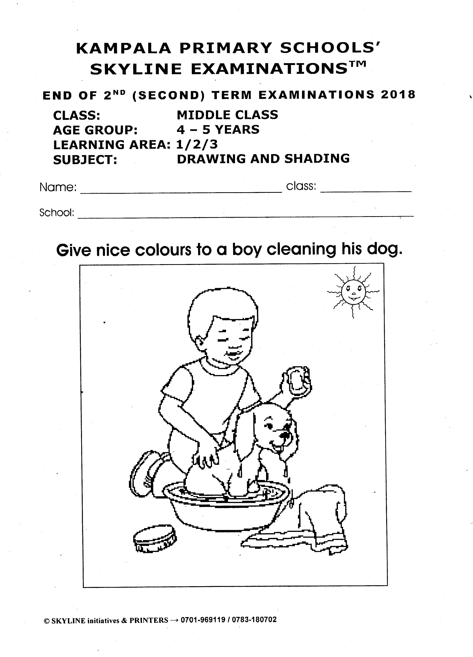

**End**